Jay Noppone Pornpitaksuk

Lab 1

CSC343

Hamed Fazli

Task 1:

1.1 Circuit Diagram:

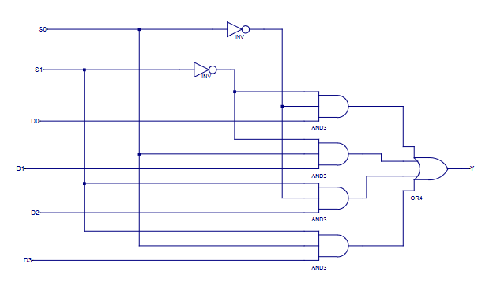

1.2 Entity, architecture, and test bench

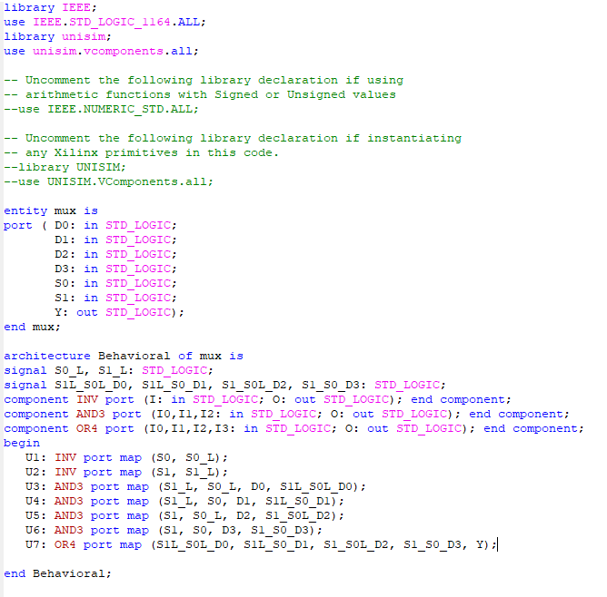

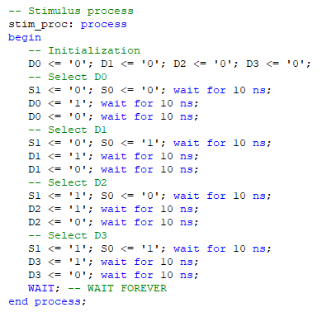

1.3 Results

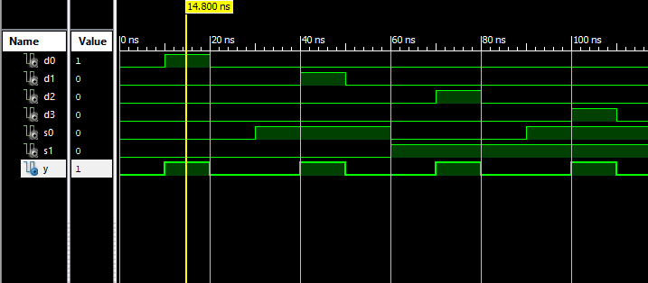

The above shows the multiplexer selecting neither S1 and S0, resulting in the result Y being D0, which is shown above to have a value of 1, while the other selections are at value 0.

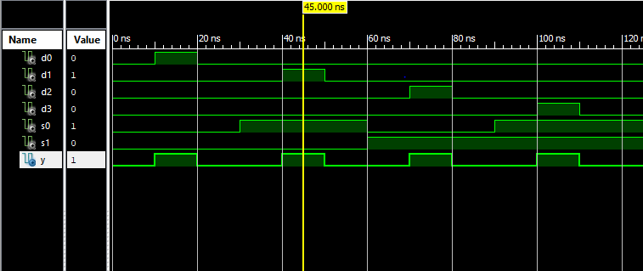

With the same reasoning as the previous image, the above screenshot shows that when S0 is 1, and S1 is 0, just like in the truth table given, the selected value in the multiplexer is D1

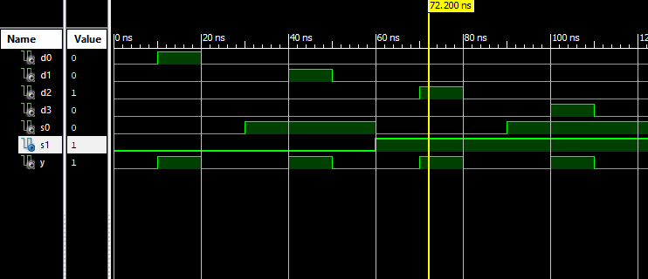

Above, our multiplexer program has S1 at the value 1, and S0 at 0. The program correctly chooses D2 as its current output value Y.

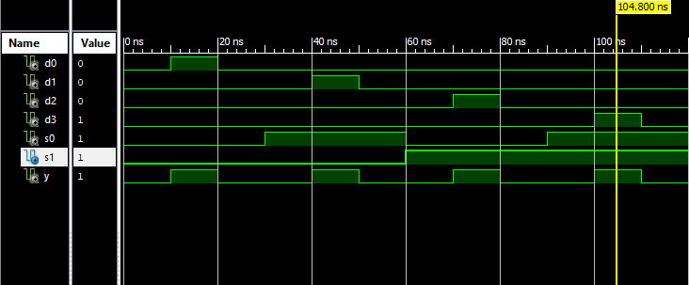

Finally, for the final output value in the truth table, both the S1 and S0 are set to 1; therefore, correctly choosing the output D3 for Y, just like shown in the truth table.

Task 2:

Task 3: